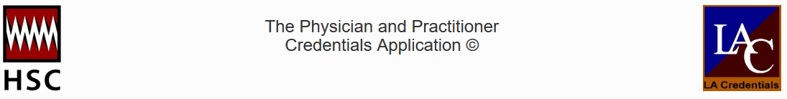

We are pleased to announce that our Standard Authorization, Attestation and Release form can now be signed electronically using DocuSign.
The DocuSign enabled process involves a few simple steps and allows you to save a copy of the release for your records. Once the form is completed, it will be sent directly to HSC for processing. By eliminating the need to send in this form separately via fax, email or through our upload screen we hope to reduce delays in the credentialing process.
The following link will redirect you to the form that needs to be completed on the DocuSign platform: DocuSign Enabled HSC Standard Authorization, Attestation and Release
Please note that the release must be signed by the practitioner and it cannot be signed on their behalf. If you are not the practitioner, please send them the link so they are able to access the form and complete it.

Reminder of items needed to complete the credentialing process
The following items are needed for the credentialing process to begin:
- HSC Online Application – please remember to submit your online application
- HSC Standard Authorization, Attestation and Release form – submit online via DocuSign
- Supporting documents listed below can be emailed to credentialing@nmhsc.com or faxed to 505-346-0287:
  - Copy of current state license
  - Copy of current medical malpractice coverage
  - Copy of current state and/or Federal controlled substance registration certificate
  - Documentation that supports any affirmative response on the Professional Practice Questionnaire, if needed

If you have any questions about our credentialing process, please contact our customer service team at credentialing@nmhsc.com or toll free to 866-908-0070 x 2006.

DocuSign provides a secure platform which allows practitioners and applicants to electronically sign documents with a digitally verified signature. DocuSign is the most widely recognized and accepted electronic signature and is accepted by a wide variety of regulatory agencies and is HIPAA compliant.

